LAB 3 – OS

GREP:

Regular expressions – way to generalize concepts

-return only the lines that start with “ANA” => “^ana”

-regular expressions teaching book (pg 13)

. – maches any single character

[a-z] – any character from a to z(any lower-case letters)

Any character that is not a digit – use the negation of the interval( use [^] = NOT)

^ => beginning of a line

[^] => NOT

[] =>all the characters that we need to match

“[abc]” != “abc”

[abc] => all characters that are a or b or c

Ana are mere.

[a-z] – applied to a single match(matches the first character =>”a”)

Ana are mere.

[a-z]+ - one ore more characters from this interval

+ =>

\*=>

Return all the lines that return a digit

$- end of a line

Return all the lines that contain only digits



Return all the lines that are empty



Return all the lines that contain at least one word with at least 2 vowels

* Define search space(word => it is surrounded by 2 spaces)
* Perform a search space => iterate from all the characters in the search space
* Search until space is found
* Add an expression “[^ ]+”
* Search for the vowel [aeiou]
* Continue with the rest of the vowels [^ ]\*[aeiou]
* End with [^ ]\*[ ]
* For the case with endline : add \* at the end

!! Hint for the test:

TEST: single problem – solve it with grep, sed, awk

* Return all the lines that contain words with 2 digit and then replace all the vowels with !
* Look for examples in teaching notes => used with /etc/passwd

(a:b:c:d: => not space, but :)

* Redo the example in class and do the exercices in the teaching notes 4.1(pg13)

SED : has many operation types(by default replace only the first occurrence)

S /(find components) /(with what we want to replace it) /

Replace only something that is at the beginning of the line

Replace the occurrence across the entire line(only a)

Replace the occurrence across the entire line(both a and A)

S =>substitute

Y =>maps characters for replacing

D => deletes all the lines that contain ‘find a component’

y/(characters to replace)/(the characters from the same position to replace the first characters)

!!! on the test

Delete all the lines that contain a digit

Capture the characters that were matched:

Ex: double all the vowels

s/([aeiou])/ \1 /gi

\1 - character that has been matched

\1\1 - replaced by the same content 2 times

Ex: switch all the vowels that are followed by a digit

s/([aeiou])([0-9])/\2\1/g

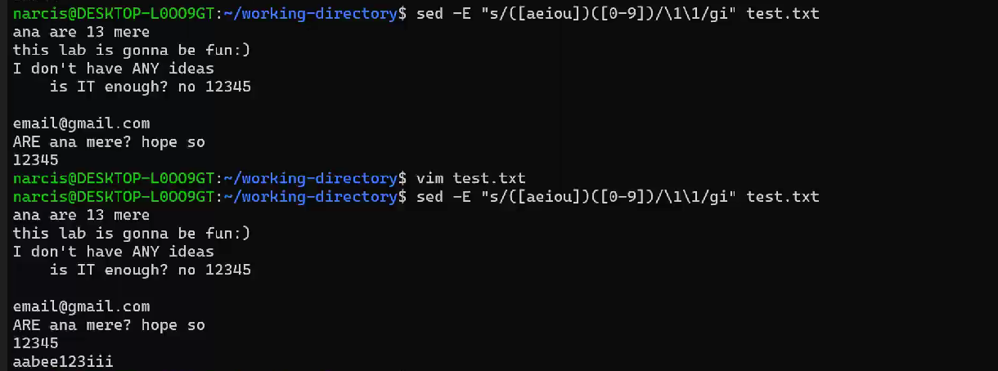

AWK-used for processing files

Awk ‘ awk scripts in a line ‘ file

{ } – bodies of code between { }

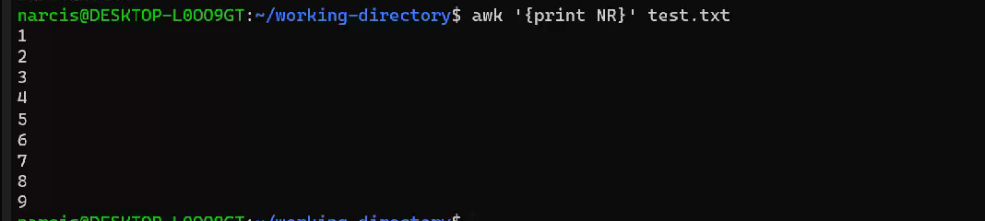

NR – number of current line

NF – number of words in a line

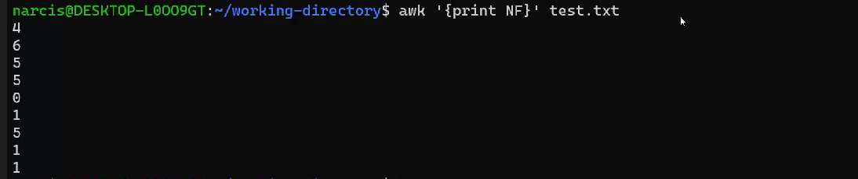

Prints the second field

Prints all the lines

Print the last field

Print all the lines that have an even number of fields



Print all the lines that have the third field a number

$3 – third field

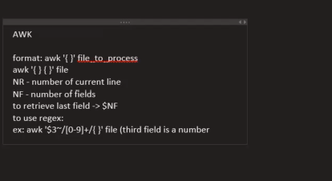

In awk you can have as many bodies - { } as you want

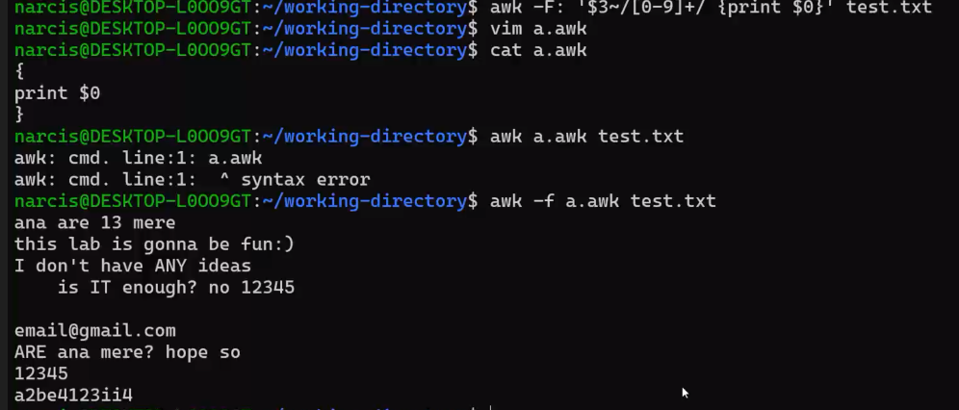

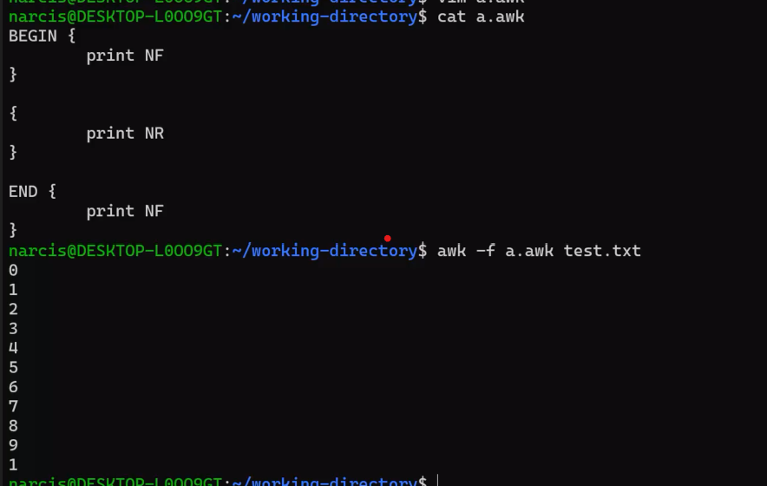

Why 0? – we do not have a line at the beginning

0 – no line loaded in the program yet

Why 1 at the end? – only something is typed in the end

Count all the lines that have an even index:

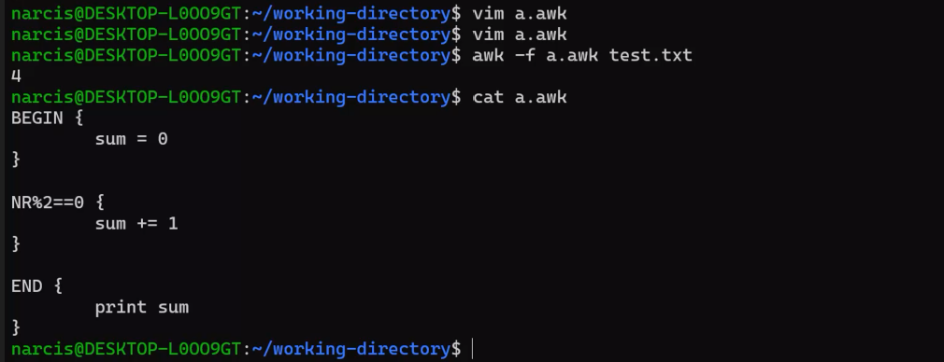

Sum of all the lines that contain only digits:

